SET 18: PRODUCT INVENTORY MANAGEMENT

Dataset | Product Inventory
Department | AIDS
Course Code / Course Name | DSA0602 / Data Handling and Visualization
Experiment | Data Visualization using R
Name | GOPIKHA S
Register Number | 1924260143
Date | 10 October 2026
Day | Saturday

Dataset: Product Inventory

Product ID | Product Name | Quantity Available | Price (in $)
1 | Product A | 250 | 20
2 | Product B | 175 | 15
3 | Product C | 300 | 18

PROGRAM 1: Bar Chart of Product Quantity
Question: Create a bar chart to visualize the quantity of each product in the inventory. Label the axes and title the chart.
# Dataset
product <- c("Product A", "Product B", "Product C") quantity <- c(250, 175, 300)

# Bar Chart
bp <- barplot(quantity,
names.arg = product,
main = "Quantity Available by Product", xlab = "Product",
ylab = "Quantity Available", col = "skyblue",
ylim = c(0, 350))

# Label each bar
text(bp, quantity, labels = quantity, pos = 3)

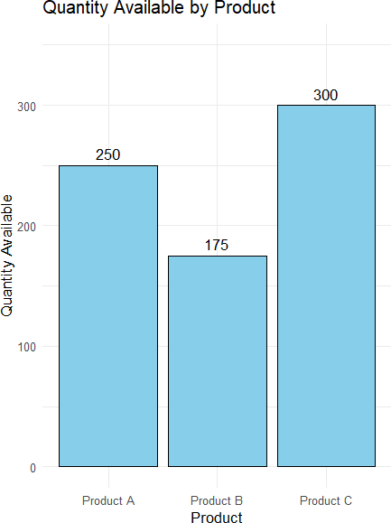

Output 1: Product Quantity Bar Chart
Observation: The bar chart shows the available quantity of each product. Product C has the highest stock (300), followed by Product A (250), and Product B has the lowest stock (175).

PROGRAM 2: Stacked Bar Chart by Product Category
Question: Generate a stacked bar chart to show the quantity of each product within different product categories.
# Dataset (the Category column is assumed, as the dataset does not give one)
inventory <- data.frame(
Product = c("Product A", "Product B", "Product C"), Category = c("Category 1", "Category 2", "Category 1"),
Quantity = c(250, 175, 300)
)

# Quantity of each product within each category
qty_matrix <- xtabs(Quantity ~ Product + Category, data = inventory)

# Stacked Bar Chart barplot(qty_matrix,
main = "Quantity by Product within Categories", xlab = "Product Category",
ylab = "Quantity Available",
col = c("skyblue", "orange", "lightgreen"), ylim = c(0, 650),
legend.text = rownames(qty_matrix), args.legend = list(x = "topright", bty = "n"))

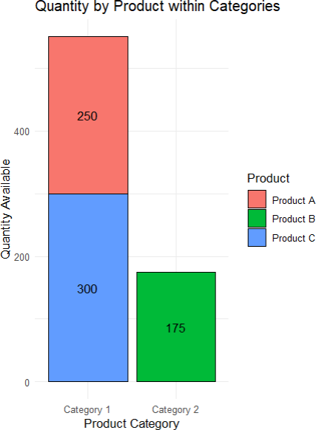

Output 2: Stacked Bar Chart of Quantity by Category
Observation: Each bar represents a product category and is stacked by product. Category 1 holds 550 units (Product A 250 and Product C 300), while Category 2 holds 175 units (Product B).

PROGRAM 3: Product Inventory Data Table
Question: Build a table to show the inventory data for each product. Label the table elements.
# Product Inventory Dataset inventory_data <- data.frame(
Product_ID = c(1, 2, 3),
Product_Name = c("Product A", "Product B", "Product C"), Quantity_Available = c(250, 175, 300),
Price = c(20, 15, 18)
)

# Display the table print(inventory_data)

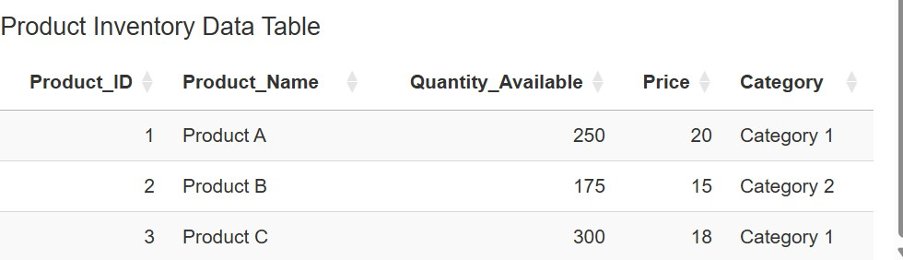

Output 3: Product Inventory Data Table
Observation: The table displays the Product ID, Product Name, Quantity Available and Price (in $) for each of the three products.

PROGRAM 4: Interactive Tableau Dashboard
Question: Develop a Tableau dashboard combining the bar chart, stacked bar chart, and the table for interactive exploration of inventory data.

Tableau Steps
- Open Tableau and connect to the Product Inventory dataset.
- Verify the fields Product ID, Product Name, Quantity Available and Price (in $); add a Category field (Category 1 / Category 2) to the data source for the stacked bar chart.
- Create a worksheet for the bar chart: drag Product Name to Columns and Quantity Available to Rows, then select Bar in the Marks card.
- Add the title “Quantity Available by Product” and label the axes.
- Create a second worksheet: drag Category to Columns, SUM(Quantity Available) to Rows and Product Name to Color to get the stacked bar chart.
- Add the title “Quantity by Product within Categories” and label the axes.
- Create a third worksheet and drag Product ID, Product Name, Quantity Available and Price (in $) into the view to form the inventory table.
- Create a new Dashboard and add the bar chart, stacked bar chart and table.
- Add the title “Product Inventory Dashboard”.
- Use Category or Product Name as a filter (click “Use as Filter”) to make the dashboard interactive.
- Test the dashboard by selecting a product/category and checking the linked views.

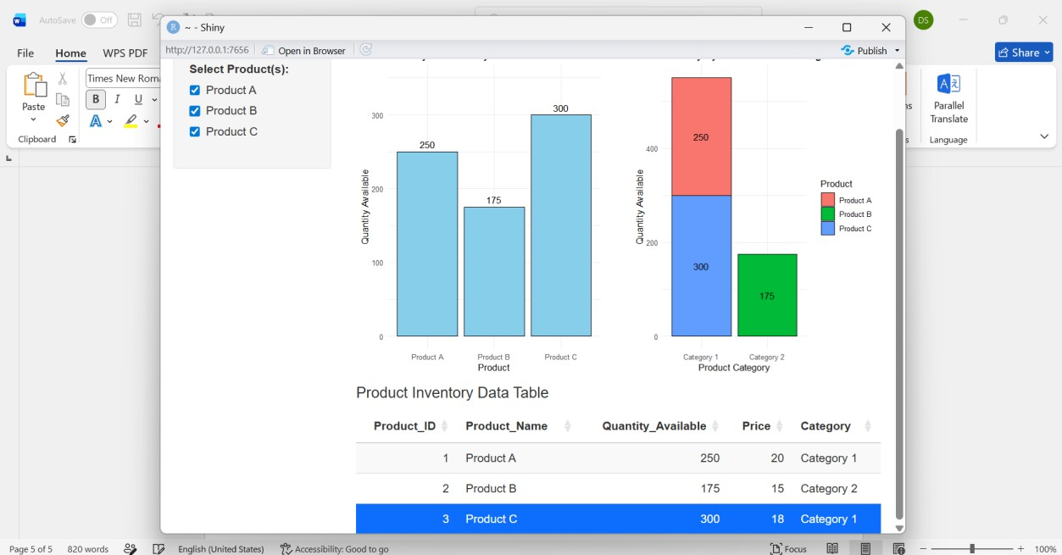

Output 4: Product Inventory Dashboard
Observation: The Tableau dashboard combines the quantity bar chart, stacked bar chart and inventory table, allowing interactive exploration of the inventory data.

Procedure
- Create the product inventory data in R.
- Prepare the quantity values and create the bar chart using barplot().
- Prepare the category data, build a quantity matrix using xtabs(), and create the stacked bar chart using barplot().
- Create a data frame containing Product ID, Product Name, Quantity Available and Price and display it as a table.
- Open Tableau and import the Product Inventory dataset.
- Create the quantity bar chart and the stacked bar chart in Tableau.
- Create the inventory data table in Tableau.
- Combine the three visualizations into an interactive dashboard and add a suitable title.
- Test the dashboard using the available filter/interactivity.

Result
The Product Inventory data was successfully visualized using a bar chart, stacked bar chart, inventory data table, and an interactive Tableau dashboard.

